Data in the Cloud
(05.2025)

INTRODUCTION
Urban pedestrian flow analysis plays a crucial role in shaping effective city planning and enhancing public safety. This assignment focuses on developing a comprehensive data pipeline to collect, cleanse, and analyze pedestrian sensor data across Melbourne. Utilizing Azure Data Factory for data ingestion and transformation, alongside Azure SQL Database for centralized storage, the project aims to uncover key patterns and trends in pedestrian movements. Through detailed analysis and visualization using Power BI, the study identifies high-traffic zones and peak pedestrian hours, providing actionable insights and recommendations to inform urban infrastructure improvements and crowd management strategies. This approach demonstrates the value of integrating cloud data analytics in modern urban planning.

1. BUILD A BIG DATA PROCESSING PIPELINE
- Power BI Dashboard
OneDrive:
https://latrobeuni-my.sharepoint.com/:u:/g/personal/22261793_students_ltu_edu_au/EZ5c_kX0QwlCha0mpH2OQB4BvFIra6YmMT7ZcnGzow0Q-g?e=EO04m4
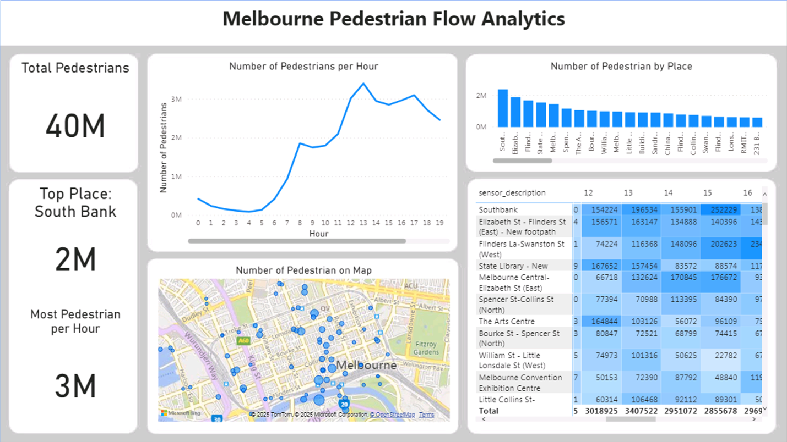
The dashboard presents a comprehensive overview of pedestrian activity across Melbourne during the study period, with a total recorded foot traffic of approximately 40 million. This high volume highlights the importance of pedestrian movement in the city, particularly concentrated in central urban areas and key transit hubs.
Analysis of pedestrian trends by hour reveals a clear daily pattern: foot traffic gradually increases from early morning, reaching its peak between noon and mid-afternoon (12 PM to 3 PM), and then remains relatively high until the evening around 7 PM. This pattern aligns with typical working hours, lunch breaks, and commute times, reflecting the natural rhythm of urban pedestrian flows.
Geographically, Southbank emerges as the busiest location with around 2 million recorded pedestrian counts, followed by other prominent areas such as Elizabeth Street – Flinders Street (East) and the State Library. The spatial distribution shown on the map confirms that pedestrian sensors are densely placed around these key zones, reinforcing their significance within Melbourne’s pedestrian network.
Furthermore, the heatmap provides valuable insights into hourly fluctuations across different locations, enabling precise identification of peak hours and high-traffic zones. This granular view supports targeted urban planning and resource allocation.
Overall, the data provides a solid basis for urban planners and traffic managers to enhance infrastructure. Suggested actions include expanding sidewalks and pedestrian paths in high-traffic areas like Southbank, optimizing traffic signal timings, and strategically positioning transit stops to accommodate peak pedestrian volumes better. Additionally, examining directional movement patterns can further aid in improving pedestrian safety and flow efficiency.
- Pipeline
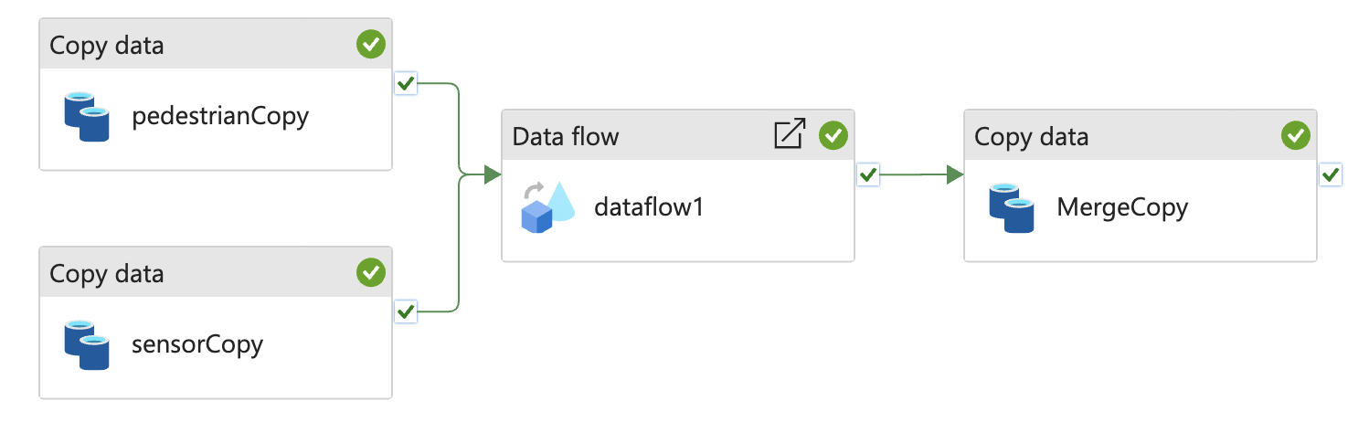
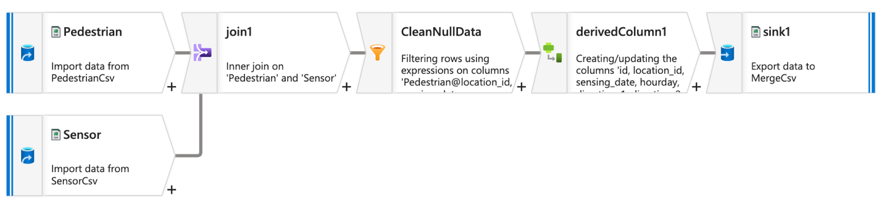
The data pipeline was designed using Azure Data Factory (ADF) to ingest, cleanse, and aggregate pedestrian sensor data collected across Melbourne. Raw data files from pedestrian and sensor sources were first loaded into Azure Blob Storage. ADF Mapping Data Flows then performed data cleansing steps to handle missing values and filter invalid records. Subsequently, data was aggregated by sensor location and hourly time buckets using transformation logic within the Data Flow. The cleaned and summarized data were then loaded into an Azure SQL Database, serving as the central repository for analysis and reporting. Power BI is connected directly to the Azure SQL Database for real-time visualization and interactive dashboards.
The analysis revealed that approximately 40 million pedestrian movements were recorded during the study period, reflecting substantial foot traffic in Melbourne’s urban core. Pedestrian flow patterns showed clear daily trends, with peak activity between noon and 3 PM, coinciding with typical work and lunch hours. Southbank was identified as the busiest area with around 2 million pedestrian counts, followed closely by locations such as Elizabeth Street – Flinders Street (East) and the State Library. Heatmaps and hourly aggregations highlighted specific high-traffic zones and times, offering valuable insights for urban planning.

Based on these findings, it is recommended that city planners focus on enhancing pedestrian infrastructure in high-traffic locations like Southbank by widening sidewalks, improving crosswalk safety, and adding shaded walkways. Optimizing traffic signals and transit stop placements to accommodate peak pedestrian hours can improve flow and safety. Additionally, implementing real-time monitoring systems leveraging sensor data would allow dynamic crowd management and efficient deployment of safety resources. Understanding directional pedestrian flows can further help design better routing to reduce congestion and improve pedestrian experiences in Melbourne.

2. CONDUCT AN EXPLORATORY ANALYSIS OF THE NYC TAXI 7 LIMOUSINE COMMISSION DATASET USING DATABRICKS
- Average fare per mile
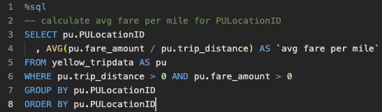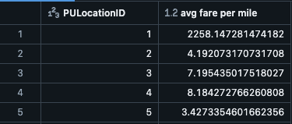
The analysis of average taxi fare per mile by pickup location reveals notable variation across different areas in Melbourne. While most locations show average fares between three to eight dollars per mile, some areas, such as the one represented by PULocationID 1, exhibit extremely high average fares exceeding two thousand dollars per mile, indicating possible data anomalies or pricing irregularities. These outliers suggest the need for further investigation to ensure fair pricing and data accuracy. Overall, this insight can help city planners and regulators identify areas where taxi costs may be disproportionately high and develop targeted policies to improve transport affordability and fairness.
- Compare the top 10 zones with the highest and lowest average fare per mile
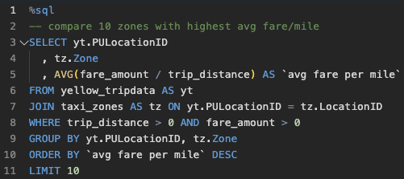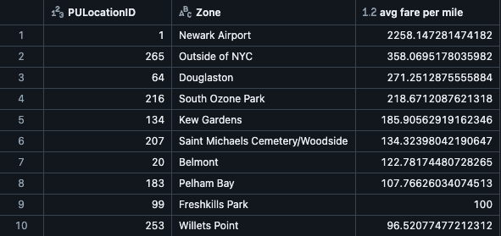
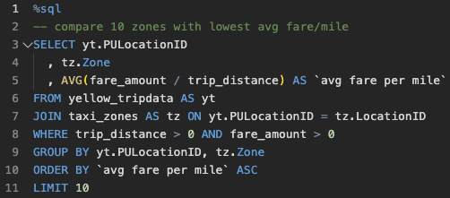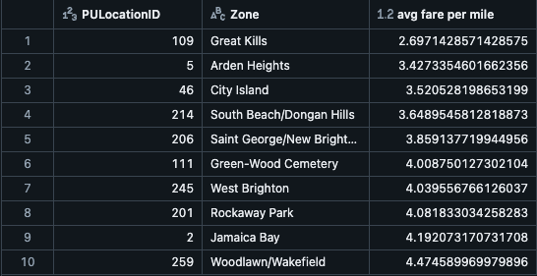
The analysis comparing taxi fare per mile across different zones reveals a significant disparity between the highest and lowest priced areas. Newark Airport stands out with an exceptionally high average fare exceeding $2,200 per mile, which is an extreme outlier likely due to data anomalies or short trips with disproportionately high fares. Other high-priced zones include areas such as Outside of NYC, Douglaston, and South Ozone Park, where fares average between approximately $200 and $350 per mile - still substantially above typical taxi rates. These high-fare zones may indicate locations with special surcharges or require further investigation to ensure pricing fairness.
Conversely, the zones with the lowest average fares per mile, including Great Kills, Arden Heights, and City Island, have rates ranging from about $2.7 to $4.5 per mile, reflecting more typical taxi pricing patterns often found in suburban or less congested areas. Other low-fare zones like South Beach/Dongan Hills and Saint George/New Brighton show similarly reasonable pricing, likely reflecting longer trips or more stable fare structures.
- Analyze potential temporal effects by repeating the analysis for peak vs. off peak hours using the tpep_pickup_datetime field.
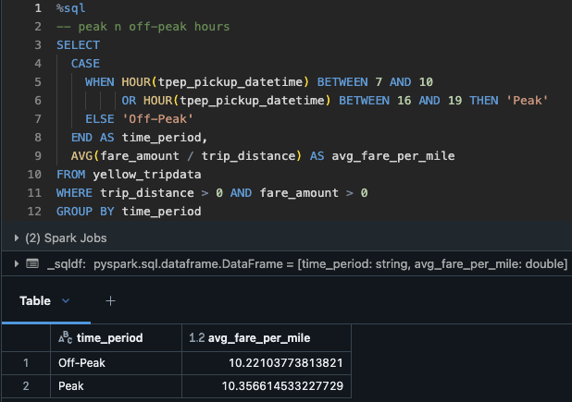
The analysis reveals signs of pricing inequities across different pickup zones in New York City. Certain areas, such as PULocationID = 1, exhibit unusually high average fares per mile - likely due to very short trips being charged a minimum fare, which skews the averages. Moreover, significant differences exist between central zones (e.g., Midtown, Airports) and outer boroughs, suggesting inconsistencies in pricing structures. This disparity is further amplified during peak hours, where passengers in high-demand areas may pay more for shorter trips due to traffic or fixed-rate policies. These findings indicate a need for policy intervention, including filtering data outliers, increasing pricing transparency, and reviewing fare policies to ensure fairness across zones.
- Count trips by PU DO Location
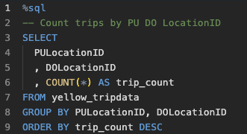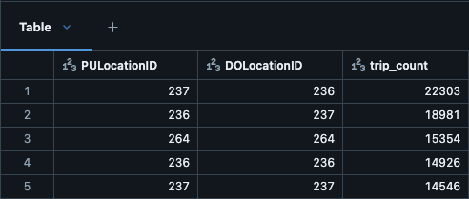
The query aggregates the total number of taxi trips between each pair of pickup and drop-off locations, ordering the results by the highest trip counts. This provides insight into the most frequently traveled routes within the dataset.
The top results reveal that the locations with IDs 237 and 236 have the highest interchange of trips, with over 22,000 trips from 237 to 236 and nearly 19,000 trips in the reverse direction. This reciprocal pattern suggests a strong travel corridor or connectivity between these two areas. Other pairs, such as locations 264 and 264, also show significant trip volumes, highlighting popular intra-zone travel.
These findings can inform urban transport planning by identifying heavily trafficked routes where improvements such as additional taxi stands, enhanced traffic management, or public transit options could alleviate congestion and better serve passenger demand.

- Top 10 PU and DO zones during morning and evening time
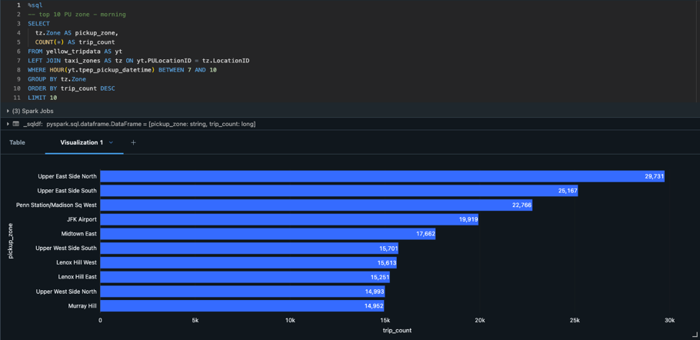
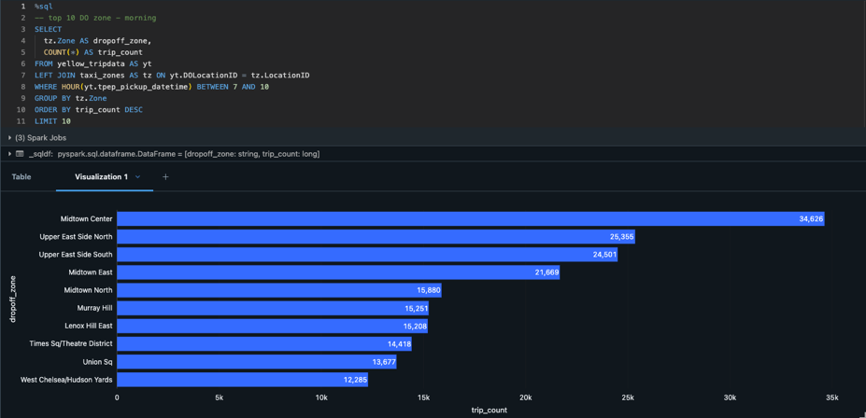
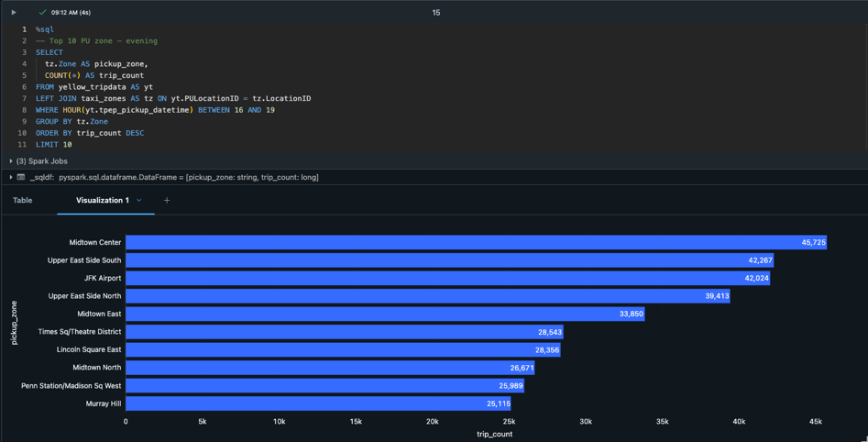
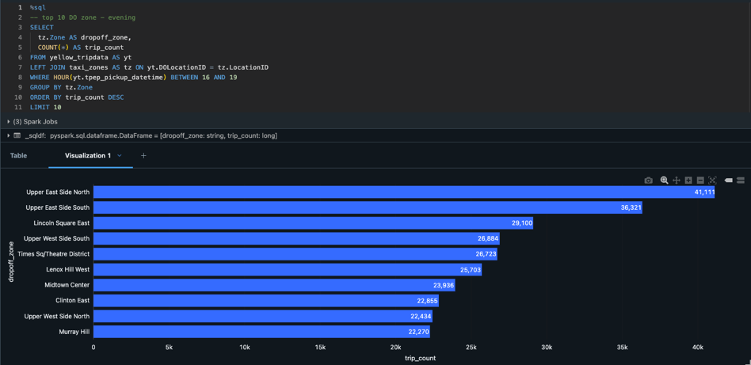
Based on the analysis of the top pickup and drop-off zones during both morning (7–10 AM) and evening (4–7 PM) peak hours, several areas consistently show high taxi demand and should be prioritized for additional taxi infrastructure. The Upper East Side North and South zones appear frequently across all charts, highlighting their role as dense residential areas with significant commuter traffic - passengers leave these zones in the morning and return in the evening. To meet this recurring demand, it is recommended that dedicated taxi bays be established near major residential intersections, particularly along high-traffic avenues. Similarly, JFK and LaGuardia Airports show strong morning drop-off and evening pickup activity, aligning with typical flight schedules. These airport zones would benefit from expanded holding areas for taxis, improved digital queueing systems, and better curbside pickup organization to reduce congestion. Midtown Center and Midtown East also rank highly during both periods, likely due to their concentration of office buildings, tourist spots, and commercial hubs. Installing smart taxi stands and real-time signage near hotels and major intersections could improve flow and availability. In the Financial District—including Battery Park and the World Trade Center area - strong morning drop-off activity indicates significant inbound commuter volume. These areas should integrate taxi pickup points more closely with existing transit infrastructure, such as subway stations and ferry terminals, to support seamless multimodal connections. Lastly, Union Square and East Village zones show consistent bidirectional flow across peak hours, suggesting that implementing dynamic taxi zones—zones that shift based on time of day - would better manage changing passenger movement patterns. Overall, the visualized data supports targeted infrastructure improvements in these zones to enhance taxi availability, reduce illegal pickups, and improve urban mobility for both residents and visitors.

